

**REMOTE MONITORING OF MDB**

**CONTROLLED DRINK VENBUS MACHINE**

|  |  |
| --- | --- |
| **USING GSM** |  |
| **A PROJECT REPORT** | |
| ***Submitted by*** |  |
| **S.KARTHIK** | **(090106126015)** |
| **S.KARTHIKEYAN** | **(090106126016)** |
| **S.NANDINI** | **(090106126021)** |

***in partial fulfillment for the course of***

**BACHELOR OF ENGINEERING *in***

**ELECTRICAL AND ELECTRONICS ENGINEERING**

**SRI SHAKTHI INSTITUTE OF ENGINEERING AND TECHNOLOGY**

**COIMBATORE-62**

**ANNA UNIVERSITY: CHENNAI 600 025**

**MAY 2013**

**ANNA UNIVERSITY: CHENNAI 600 025**

**BONAFIDE CERTIFICATE**

Certified that this project report **“REMOTE MONITORING OF MDBCONTROLLED DRINK VENBUS MACHINE USING GSM”** is the bonafide work of

|  |  |
| --- | --- |
| **S.KARTHIK** | **(090106126015)** |
| **S.KARTHIKEYAN** | **(090106126016)** |
| **S.NANDINI** | **(090106126021)** |

who carried out the project work under my supervision.

**SIGNATURE SIGNATURE**

**Mr.S.PALANI KUMAR, M.E., MISTE** **Mr.R.ASHOK ,**

Head of the Department and Assistant Professor (SG),

Assistant Professor (Senior), Department of Electrical and

Department of Electrical and Electronics Engineering,

Electronics Engineering, Sri Shakthi Institute of Engineering

Sri Shakthi Institute of Engineering and Technology, Coimbatore-62

and Technology, Coimbatore-62

Submitted for project and viva-voce held on …………….

-------------------------------------------- --------------------------------------

**INTERNAL GUIDE EXTERNAL GUIDE**

**ACKNOWLEDGEMENT**

We sincerely express our deepest gratitude to **Dr. S Thangavelu**, Chairman, **Sri Shakthi Institute of Engineering and Technology** for his continuous encouragement and support throughout our course of study.

We would like to extend our sincere thanks **to Er.T.Dheepan,** secretary, **Sri Shakthi Institute of Engineering and Technology** for this encouragement.

We would like express our gratefulness to our principal **Dr.S.K.Sekar**, for his magnanimity in allowing us to avail the facilities in the department.

We are grateful to **Mr.S.Palanikumar,** Assistant Professor(Senior) and Head of the Department, Department of Electrical & Electronics Engineering, for providing us with the necessary facilities and encouragement, which aided the successful completion of the project work.

We would like to thank our project coordinator **Mrs.K.Indira Devi,** Assistant Professor (Senior), Department of Electrical &Electronics Engineering, for her support during the entire course of this project work.

We would like to extend our gratitude to **Mr.A.Prakash,** R&D Head, **LogIT Private Limited, Coimbatore.**

We thank our supervisor **Mr.R.Ashok,** Assistant Professor (SG), Department of Electrical &Electronics Engineering for his guidance, supporting and encouragement and also his creative thinking in given idea.

We would like to extend our thanks to all the faculty members of our department and non-teaching staff for their timely support.

**ABSTRACT**

Vending machine manufacturing is farily new industry in India. Estimates shows that global sales through vending is 40% for canned beverages, 19% for snacks, 8% for hot beverages and 33% for other products[1]. Drivers for vending machine connectivity come from people, business and society in general. With over 18 million vending machines installed worldwide as on 2010, technologies such as telemetry and MDB (multidrop bus) gain importance for future installations. The new breed of vending machines which support both telemetry and multidrop bus connectivity have the high market potential in coming years. We name them as “**Vend bus Machines**”. Few entreprenuers are in the verge of creating a company for manufacturing this vend bus machines. They requested us to develop a prototype, which can be further improved to be showcased to potential investors, in seeking seed fund.

Our prototype currently supports features such as remote management, wireless authentication, automated transactions, real time transaction updates and alerts & notification through SMS. Our prototype also enables zero maintenance cost and 24x7 effective & efficient monitoring.

. The machine vends hot and cold drinks according to the user’s selection. LCD display is used to display the selection to the user. The transaction details such as transaction time, item, quantity, and the sales amount are monitored remotely via GSM. A standard protocol called MDB/ICP is chosen for its unique features such as support of wide range of devices and currencies. For demonstration purpose, virtual MDB is created using LabVIEW..

Our system also generates alerts and notifications when the stock in the tank is empty so that administration can initiate the refilling process..

**TABLE OF CONTENTS**

**PAGE NO**

ABSTRACT……………………………………………………………......

TABLE OF CONTENTS………………………………………………......

LIST OF FIGURE……………………………………………………….....

LIST OF ABBREVIATIONS………………………………………………

**CHAPTER 1 INTRODUCTION…………………………………….**

1.1 PROJECT PROBLEM STATEMENT..................................

1.2 PROJECT OBJECTIVES.....................................................

1.3 PROJECT SCOPE................................................................

1.4 SYSTEM OVERVIEW……………………………………….

**CHAPTER 2 LITERATURE SURVEY……………………………**

2.1 INTRODUCTION…………………………………………….

2.3 MARKET SURVEY………………………………………….

2.4 STATISTICS………….………………………………………

2.5 EXISTING SYSTEM…………………………………….......

2.7 PROPOSED SYSTEM……………………………………….

**CHAPTER 3 METHODOLOGY……………………………………**

3.1 REQUIREMENT ANALYSIS……………………………….

3.2 HARDWARE DESIGN………………………………………

3.2.1 POWER SUPPLY………………………………………

3.2.2 SENSOR MODULE……………………………………

3.2.3 GSM MODULE…………………………………………

3.2.4 DISPLAY MODULE……………………………………

3.2.5 EEPROM……………………………………………......

3.2.6 DRIVER MODULE…………………………………….

3.2.7 CONTROL UNIT MODULE…………………………..

3.22.8 MDB MODULE………………………………………...

3.3 SOFTWARE DESIGN………………………………………..

3.3.1 MODULAR DESCRIPTION………………………......

3.3.2 FLOW CHART……………..…………………………..

**CHAPTER 4 IMPLEMENTATION…………………………………**

4.1 PROTEUS SIMULATION……………………………………

4.2 CODING……………………………………………................

4.3 LABVIEW VI DEVELOPMENT…………………………….

4.4 SYSTEM INTEGRATION……………………………………

**CHAPTER 5 CONCLUSION…………………………………………**

5.1 FUTURE WORK………………………………………………

5.2 REFERENCE………………………………………………….

**ANNEXURE…………………………………………………….................**

**A** DATA SHEET………………………………………………....

**B** APPENDICES………………………………………………….

**LIST OF TABLES**

**TOPICS PAGE NO**

|  |  |  |
| --- | --- | --- |
| 1 | Function Table of MAX232 |  |
| 2 | Electrical Characteristics of NTC |  |
| 3 | Mechanical Characteristics of NTC |  |
| 4 | Electrical Characteristics of ULN |  |
| 5 | Truth Table of NAND |  |
| 6 | Operating Conditions of DM7400 |  |
| 7 | Electrical Characteristics of DM7400 |  |
| 8 | Electrical Characteristics of BC547 |  |
| 9 | Electrical Characteristics of ATmega128 |  |
| 10 | DC Characteristics of DM7400 |  |
|  |  |  |
|  |  |  |
|  |  |  |

**LIST OF FIGURES**

**TOPICS PAGE NO**

|  |  |  |
| --- | --- | --- |
| 1 | Interaction Diagram |  |
| 2 | Market size and revenue |  |
| 3 | Market forecast |  |
| 4 | Statistics |  |
| 5 | Circuit Diagram of Power Supply Unit |  |
| 6 | Working Model |  |
| 7 | Block Diagram Panel |  |
| 8 | Front Panel |  |
| 9 | Pin Diagram of ULN 2003 |  |
| 10  11  12 | Pin Diagram of DM7400  Pin Diagram of BC547  Pin Configuration of ATmega128 |  |
|  |  |  |

**LIST OF ABBREVIATIONS**

GSM Global System for Mobile Communications

MDB Multi Drop Bus

Lab VIEW Laboratory Virtual Instrumentation Engineering Workbench

LCD Liquid Crystal Display

IR Infra-Red

### SIM Subscriber Identity Module

SD CARD **S**ecure Digital Card

EEPROM Electrically Erasable Programmable Read-Only Memory

DTE Data terminal equipment

DCE Data Circuit-terminating Equipment

RTC Real Time Clock

IDE Integrated Development Environment

LED Light Emitting Diode

NTC Negative Temperature Coefficient

RMS Root Mean Square

**CHAPTER 1**

**INTRODUCTION**

A vending machine is a machine which dispenses items to customers automatically, after the customer inserts currency or credit into the system.

**1.1 PROJECT PROBLEM STATEMENT**

The vending machines so far installed by various enterprises on a global scale have considerable drawbacks. To have an efficient vendbus machine that could wipe out the drawbacks of the existing ones are the need of the hour.

The machines installed till now are partially monitored by human. Therefore the need for more number of persons arises. To remotely monitor the vendbus a system needs to be devised.

In a highly dense people environment the vendbus usually gets extinguished soon and also there is a chance of vending machines gets vandalized. To provide a safer machine is also on the cards.

A GSM module is interfaced with the existing system that provides instant information about the number of drinks dispatched and number of drinks left over. This GSM can also use to authenticate persons (only administrator) to access the system which provide are increased level of security.

**1.2 PROJECT OBJECTIVES**

The objective of the proposed system is to provide complete automation and security. Security of machines is achieved through wireless authentication with the help of GSM (Global System for Mobile Communications).

The primary objective is to Design-Develop-Deploy (D3), a control system for drink vendbus machine to meet the criteria’s which are as follows,

* + - * Remote Management
      * Wireless Authentication
      * Automated Transactions
      * Real Time Transaction updates
      * Alerts & Notification through SMS

The secondary objective is to ensure the following factors such as,

* + - * Zero Maintenance Cost
      * 24x7 Effective & Efficient Monitoring

**1.3 PROJECT SCOPE**

By implementing this project, a sophisticated vending machine can be made available to the common man. The number of vending machines in the public places can be increased.

More a synchronized mechanism can be bought in which could simultaneously monitor the status of more than one vending machine. This could be an added advantage to the companies as their market can be steadily increased over a period of time.

**1.4 SYSTEM OVERVIEW**

**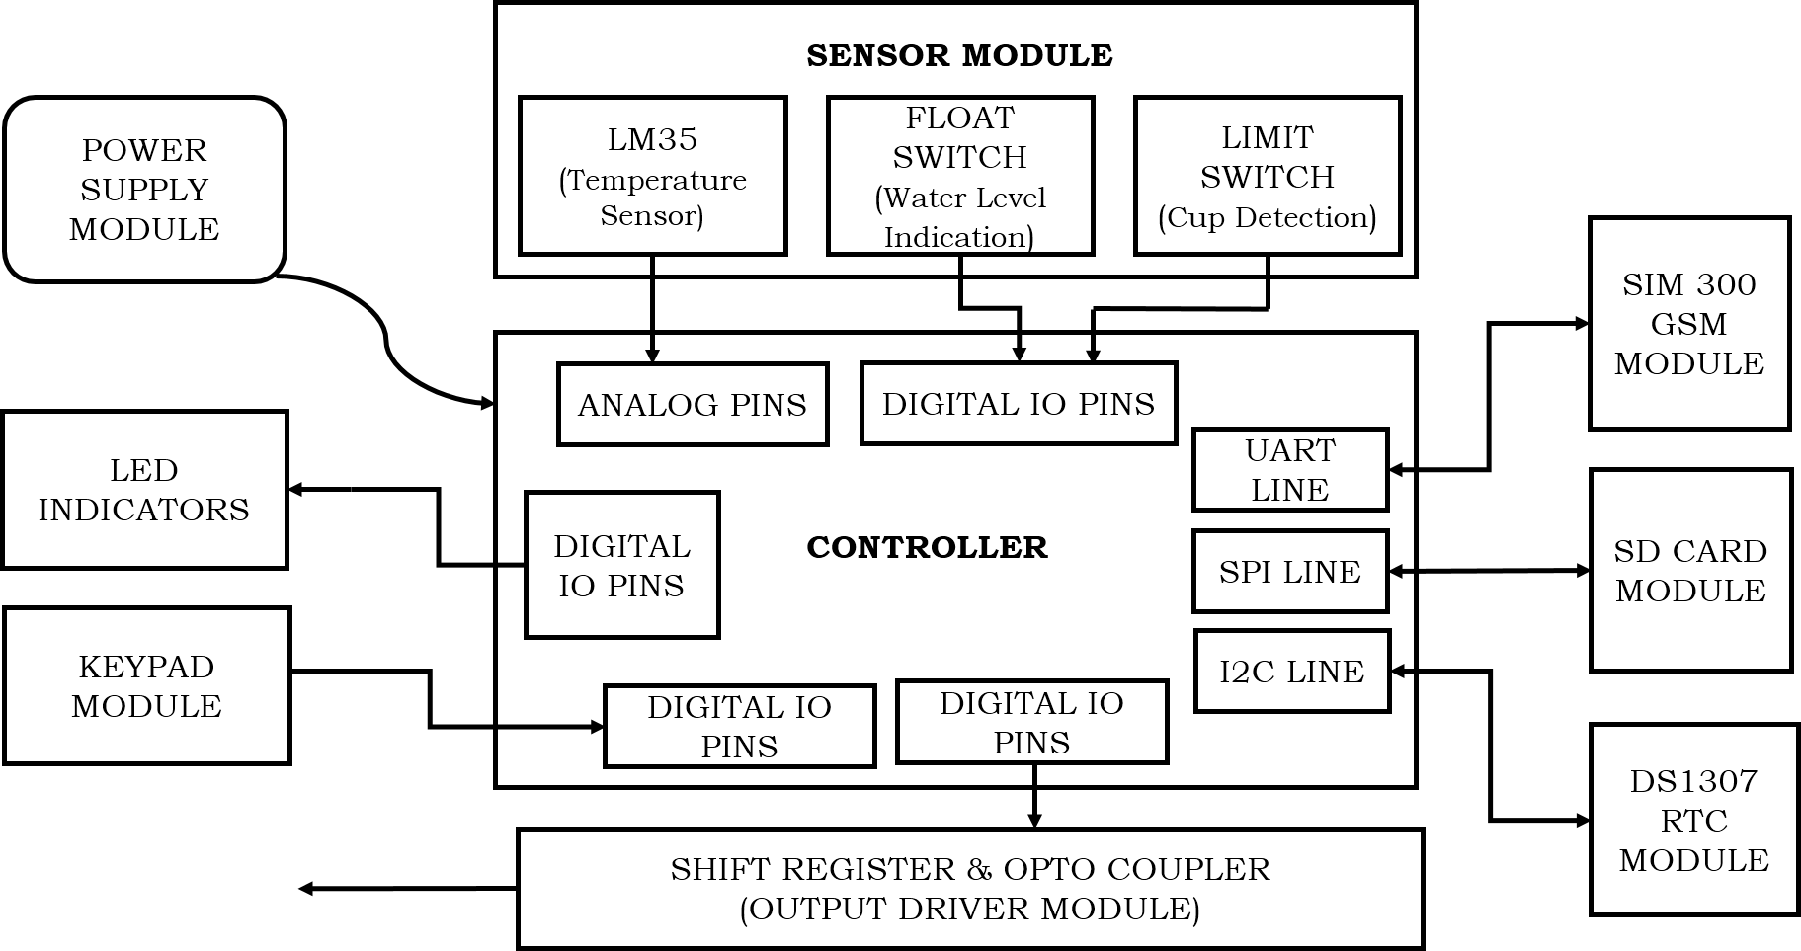**

**Fig 1.4 Interaction Diagram**

The system broadly consist of two modules a controller module and a sensor module. The sensor module is embedded with a Thermistor, a Float Switch and a limit switch. The Thermistor is connected to analog pins of the controller the float switch and the limit switch and the LED indicators are connected to the digital pins. GSM module is interfaced with the UART terminal.For storing the datas of the previous transaction a SD card module is used which is connected to the Serial Peripheral Interface of the microcontroller. A real time clock is used in the system to store the time of the transaction in the database. To select the drinks the user is provided with keyboard.

**CHAPTER 2**

**LITERATURE SURVEY**

**2.1 INTRODUCTION**

Vending machines are not very common in India and are usually found only in major cities or along some national highways. Several reasons have been attributed to the lack of success of vending machines in India; cheap labor is readily availability and has led to the setting up of several small stores throughout the country which serves as indirect competition to vending machines, a lack of technical knowledge and unease with using vending machines, problems with currency recognition and a lack of machines that accept both coins, notes and alternate payment channels, vandalism and rough use, and poor maintenance of the machines. However, vending machines are a relatively new industry in India and analysts believe that usage will rise with changing consumer habits and lifestyle.

The following are the merits of Vending Machines as efficient marketing channels

* **The Neo-Indian Consumer Factor**
* **Greater Distribution**
* **Increased Market Penetration**
* **Enhanced Visibility**
* **Effective Advertisement Platform**
* **Silent Salesman**
* **Guaranteed Quality**

**The Neo-Indian Consumer Factor:** For starters, the emergence of the Neo-Indian consumer driven by changing lifestyle and consumption patterns and the percolating consumerism effect has created a burgeoning market and increased demand.

**Greater Distribution:** Manufacturers and company’s alike benefit by utilizing Vending Machines as an efficient distribution channel for their products by appropriately locating them in spaces liable to see high footfall from the target demographic.

**Increased Market Penetration:** At a fraction of the cost incurred, these machines provide companies with the chance to penetrate new markets without the hassle of hiring too much labor. These machines bring the company one step closer to the eventual consumer; thereby, serving an intermediary role.

**Enhanced Visibility:** Companies willing to sell their products through Vending Machines stand to gain from increased visibility in an already cluttered market. Hence, the machines not only serve as a distribution unit but also serve as a display unit, creating enhanced visibility and brand recognition.

**Effective Advertisement Platform:** In addition to just merely offering products for sale, the machines also serve as an effective advertisement vehicle; thereby, aiding companies to establish a more holistic interface with the consumers and ensure higher brand recall in the long run.

**Silent Salesman:** Bereft of any human intervention whilst selling, the machines negate the adverse implications of low productivity as a consequence of employee leave, holiday or strikes. These machines function 24 hours a day, 365 days a year serving customers.

**Guaranteed Quality:** Vending Machines store quality products in a quality, safe, secure and hygienic environment. This also reduces the chances of adulteration and duplication that can hurt the prospects and credibility of the company.

Another major reason is consumer habits which are difficult to change and can only evolve over a longer period of time. Indian consumers are relationship driven and seek service, personal touch, interaction and sometimes bargaining satisfaction. Automated vending is a very impersonal vending proposition. People are yet not very comfortable using these machines because of complications, literacy, technology exposure, trust and such other factors. If that was not all the machines themselves are not completely suitable for Indian conditions. Machines often break down because of dust, heat etc. Operators loose because of vandalism and rough usage at public places. The pricing of products is such that it is not convenient to pay through coins. Club that with multiple shapes and continuously changing coins and you have a massive problem at hand. The currency recognition (especially of notes) has been an issue.

Top all of the above with the unfavorable regulations governing the Indian retail sector. India is one of the very few countries in the world having the concept of the Maximum Retail Price. This results in low margins that are not sufficient to cover even the operation costs, forget the interest and depreciation.

**2.2 MARKET RESEARCH**

**PLACES OF CUSTOMER ATTRACTION**

As of now, hot beverages vending machines for tea and coffee have the substantial share in sales of machines in India. These machines are mostly found in offices, shopping-malls and restaurants. However, sales of snacks and beverages machine are picking up and have a huge potential.

Potential locations where these machines are installed are,

1. Train-Stations 2. Airports

3. Universities 4. Shopping-Malls

5. Offices 6. Hospitals

7. Hotels 8. Fuel-Pumps

**THE BUSINESS ASPECTS**

Manufacturing of vending machines is just like any other manufacturing activity. Most of the components required to manufacture or assemble a machine are available in India.

**GROWTH DRIVERS OF THE INDUSTRY**

* Changing lifestyles, eating and drinking habits
* Consumerism due to increasing incomes (economic growth)
* Upcoming urban centres and corporate culture
* Technology (making vending easy and convenient)
* Fairly new industry & large part of market is yet to be tapped.

There are many ideas which can boost the business of vending machines for sales,

* **Type of machine**
* **Location**
* **Technology incorporation**
* **Products**
* **Price**

Also new vending machines available in the market have the option to accept currency (both notes and coins), give the change back in terms of notes and coins, accept payments through cash cards etc.

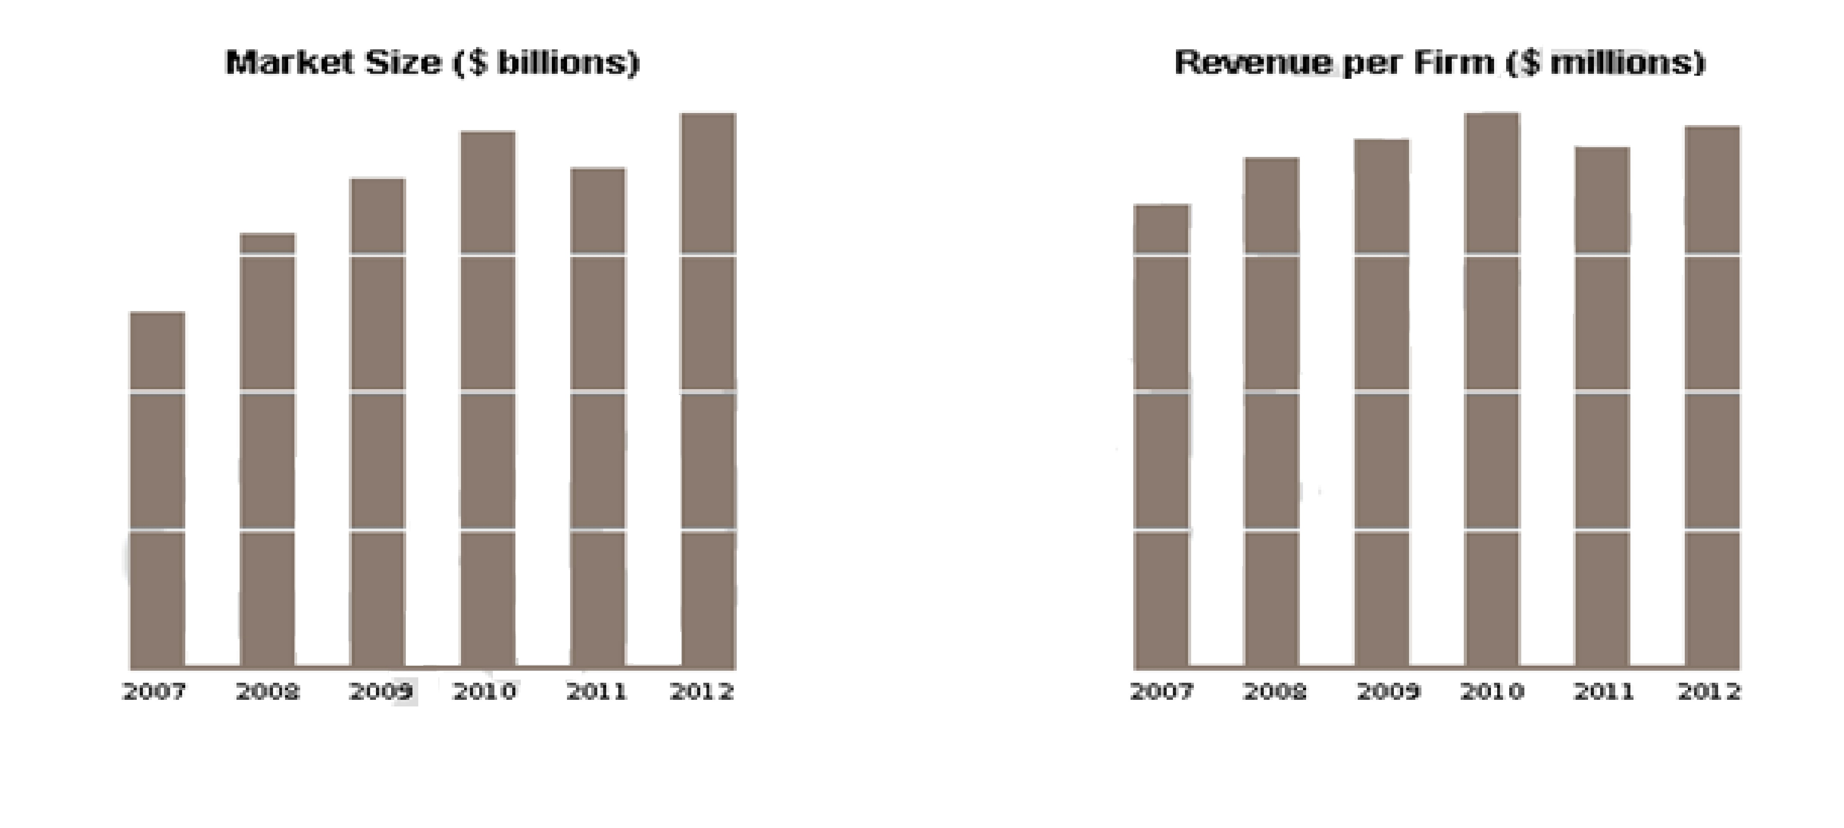**Fig 2.2 Market size and revenue**

Market forecasts show the long term outlook & future growth trends for Vending Machine Operators. The following five-year forecast utilizes advanced econometric techniques that project both short-term and long-term market growth trends.

**2.3 STATISTICS**

Sales of goods and services through vending machines crossed $1 billion in 2012. According to PulinDani of plus Beverages, a vending machine manufacturer, approximately 12-15% of the potential market for vending machines has been tapped in India till now. So, a huge market is still untapped.

|  |  |
| --- | --- |
| **PRODUCTS/GOODS** | **% OF MARKET SHARE** |
| Canned beverages | 40 |
| Snacks | 19 |
| Hot beverages | 8 |
| Other products | 33 |

**Table: Statistics**

Statistical data showing the annual revenue increase per frim & increase in market size over the years,

**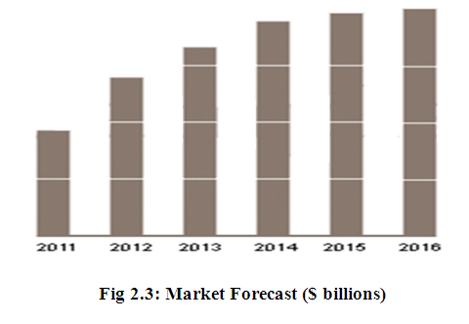**

**QUICK FACTS**

Vending machine industries are,

* Fairly new industry in India.
* Valued to be a $1 billion industry in 2012.
* Changing lifestyle, technology, consumer behaviour.
* Expected to influence business significantly.
* Only 15% of the market captured till date.
* Machines available on rent too.
* Business point could be supported by just operating 4-5 machines.

Industry Products includes the following,

* Soft drinks
* Food
* Toys
* Games
* Tobacco products

The cost of a vending machine depends upon its size, sophistication, payment system and other special features. A typical, small, basic snack & beverage vending machine costs around Rs 40,000 in India on the lower side. A hot beverage machine costs around Rs 10,000 on the lower side.

According to a study by the National Automatic Merchandising Association (NAMA), scale of operation does affect the profitability of the operators. However, according to Pulin, businesses can be operated with just 4-5 machines and still be profitable in India.

Cashless vending now allows consumers to use debit cards or pre-charged key such as the U-Key for added convenience. Vending is a multi-billion dollar industry. Cashless payments will soon be on many vending machines in the near future. The majority of vending machine operators plan to add credit card swipers to their machines in 2011, according to a study by Apriva, wireless transaction Services Company.

**CHAPTER 3**

**METHODOLOGY**

**3.1 OVERVIEW**

The hardware that are required for the our system are as follows,

1. Micro controller - ATmega128
2. Keypad - 16\*2 Matrix
3. Motor Driver - OptoCoupler (+12V DC motor)
4. SD card - SD Module
5. Display unit - 4\*16 GLCD
6. GSM unit - SIM 300 Module
7. sensors - Thermistor, Cup Detector, Water Level Indicator
8. Shift Register - 74LS595
9. RTC -DS1307
10. Relay -Dual channel HK Relay
11. EEPROM -ST 25C02
12. Solenoid Valve -12V
13. Motor -12V DC motor

**3.2 HARDWARE DESIGN**

**3.2.1 POWER SUPPLY**

Power supply is a reference to a source of electrical power. A device or system that supplies electrical or other types of energy to an output load or group of loads is called a power supply unit.

**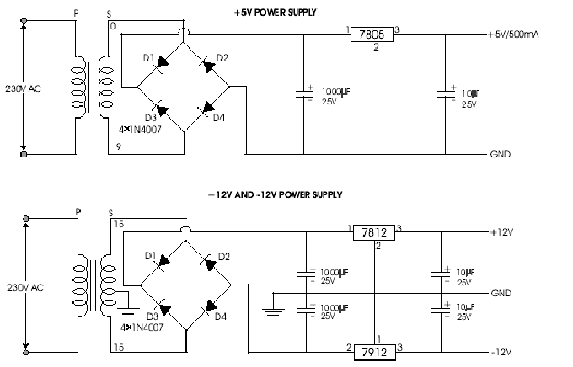**

**Fig 3.2.1 Circuit Diagram of Power Supply Unit**

This typically involves converting 240 volt AC supplied by a utility company to a well-regulated lower voltage (+/-12V) DC for electronic devices.

The ac voltage, typically 220V rms, is connected to a transformer, which steps that ac voltage down to the level of the desired dc output. A diode rectifier then provides a full-wave rectified voltage that is initially filtered by a simple capacitor filter to produce a dc voltage. This resulting dc voltage usually has some ripple or ac voltage variation.

A regulator circuit removes the ripples and also remains the same dc value even if the input dc voltage varies, or the load connected to the output dc voltage changes. This voltage regulation is usually obtained using one of the popular voltage regulator IC units.

**3.2.2 SENSOR**

The sensors that are used in this system are,

1. IR sensor

2. Thermistor

**3.2.2A IR SENSOR**

The IR transmitter is a type of LED which emits the infrared rays and the IR Receiver receives those IR ray. Both IR transmitter and receiver should be placed straight line to each other.

The transmitted signal is given to IR transmitter whenever the signal is high, the IR transmitter LED is conducting it passes the IR rays to the receiver. The IR receiver is connected with comparator. The comparator is constructed with LM 741 operational amplifier. In this circuit the reference voltage is given to inverting input terminal. The non-inverting input terminal is connected IR receiver. When interrupt the IR rays between the IR transmitter and receiver, the IR receiver is not conducting. So the comparator non inverting input terminal voltage is higher than inverting input. Now the comparator output is in the range of +12V.

**3.2.2B THERMISTOR**

A thermistor is used to sense the temperature and is composed of sintered semi-conductor material. It exhibits a large change in resistance proportional to a small change in temperature.

**3.2.3 GSM**

GSM is designed with a moderate level of security. The system was designed to authenticate the subscriber using a pre-shared key and challenge-response. Communications between the subscriber and the base station can be encrypted. The development of UMTS introduces an optional USIM, that uses a longer authentication key to give greater security, as well as mutually authenticating the network and the user - whereas GSM only authenticates the user to the network and not vice versa. The security model is achieved and thereby authentication.

**3.2.4 LIQUID CRYSTAL DISPLAY**

An LCD display is a digital display that displays the selection menu for the drinks to the user. The display also shows the real time updates whenever the system gets ON. The temperature changes and the tank status are shown in the display panel. Initially when the system gets ON the password for the system is asked in the display. When the administrator enters the correct password, the panel displays the selection menu. The following things are shown in the LCD,

GSM INITIALISATION

PLEASE ACTIVATE THE DEVICE

PASSWORD CORRECT

HOT=100 COLD=100 L: F

TIME T: L

**3.2.5 EEPROM**

EEPROM used in this project is ST 25C02 which is used for storing the transaction details. The ST25C02 is a 4Kbit electrically erasable programmable memories (EEPROM), organized as 2 blocks of 256 x8 bits. The memories are compatible with the I2C standard, two wire serial interfaces which uses a bi-directional data bus and serial clock.

**3.2.6 MAX 232**

In telecommunications, MAX-232 is a standard for serial binary data interconnection between a DTE (Data terminal equipment) and a DCE (Data Circuit-terminating Equipment). It is commonly used in computer serial port

The MAX 232 IC used as level logic converter. The MAX232 is a dual driver/receiver that includes a capacitive voltage generator to supply EIA 232 voltage levels from a single 5v supply. Each receiver converts EIA-232 to 5v TTL/CMOS levels. Each driver converts TLL/CMOS input levels into EIA-232 levels.

**3.2.7 SOLENOID VALVE**

A 12V operated solenoid valve is used in this project. It is used to control the flow of the drinks when the user opts for any drink. The solenoid valve is driven by a relay (i.e.) when the controller unit output of a relay is high; the relay activates the solenoid valve. The solenoid valve then opens and allows the flow of drink into the cup. The opening interval time of the valve is set in the microcontroller code.

**3.2.8 MICROCONTROLLER**

Search for a cost effective microcontroller resulted in the finding of ATMEL Family of Microcontrollers. The microcontroller used in the project is AT89C51 an 8 bit controller. The on-chip flash allows the program memory to be reprogrammed in-system or by a conventional non volatile memory programmer. By combining a versatile 8-bit CPU with Flash on a monolithic chip, the Atmel AT89C51 is a powerful microcomputer which provides highly-flexible and cost-effective solution to many embedded control application

**3.2.9 MDB MODULE:**

MDB/ICP is a standard vending machine protocol, used to interfaces devices like coin collector, cash exchanger. Primarily these devices are used to detect & accept currency from the user, & in turn returns the balance amount to the user. These standards were being developed by NAMA [National Automatic Merchandising Association].Cash Exchanger typical accepts currencies rs5, 10, 20 & 50 from the user. It accepts the currency, detects & types A, type B, type C, type D, respectively. Typically rs1, 2, 5 coin can be dispensed from the device.

**3.3SOFTWARE DESIGN**

**3.3.1 MODULAR DESCRIPTION**

The modules that has been used in the proposed system are

1. Sensor Module
2. Keypad Module
3. Led Indication & Display Module
4. Output Driver Module
5. Transaction Definition Module
6. Stock / Sales Maintenance Module
7. GSM Module

**1. SENSOR MODULE:**

The system needs continuous monitoring of temperature, water level & presence of cup.

1. **Temperature Measurement**

Since it operates at two modes, there are two ranges of temperature measurement.

1. Hot (600C - 800C) & 2.Cold (40C – 10 0C)

If the temperature is out of range, the machine moves to HALT STATE.

1. **Water Level Indication**

It has two tanks, the upper tank with an outlet valve & the sump tank with a pump. If water in upper tank is below the cut off value, pump it from sump tank & if no water in sump, then machine moves to HALT STATE.

1. **Cup Sensor Detection**

The cup senor detects the presence/absence of cup. In the absence of cup, the machine moves to HALT STATE.

2. **KEYPAD MODULE**

Drinks have been grouped into HOT and COLD. The 6\*6 Matrix keypad is used to get the input from the user. The input selections are enabled depending upon the amount entered by the user. Only drinks within the entered range are made available to the user & others not in the range will be disabled. Cost of each drink may be same or it may vary from one another.

**3. LED INDICATION & DISPLAY MODULE:**

In order for easier identification of available drinks to the user, each selection menu has an LED, which glows depending on the availability of the drink & the amount which the user enters. The selection becomes invalid if the user selects any disabled drinks. It prompts to select the enabled drinks with a message. It also has an LCD unit which displays appropriate messages to the user.

**4**. **OUTPUT DRIVER MODULE:**

Based on the user selection, drink has to be prepared which in turn needs different motors & valves to be driven. The driver module provides electrical isolation between drives & the control unit. Optocoupler provides the isolation between the drives & the controller. It uses shift register for driving different drives with less number of IO lines. Based on the number of drives, shift registers can be cascaded in series.

**5. TRANSACTION DEFINITION MODULE**

Each time the user selects a drink & takes up, is accounted to be transaction. Transaction can either be successful or un successful depending on the availability of drink & other factors such as Insufficient Balance, Raw Material Shortage, Administrative privileges. Administrator is only authorized to enable or disable the drinks. For each successful transactions, sales count is incremented by 1 & stock count is decremented by 1.Unsuccessful transactions are being discarded.

**6. STOCK / SALES MAINTENANCE MODULE:**

Once the raw material is filled, the stock is incremented by predefined number of counts. Real time Stock/Sales updates through GSM. It also sends an end of the day count to the administrator with the number of transactions made, stock/ sales inventory. For backup, the transaction details are also saved in the SD Card. It automatically creates a new text file for each day.

**7. GSM MODULE**

GSM is used for wireless Authentication & Remote Management, Password authentication on machine restart, real Time stock/sales updates and Alerts/Notifications generation for events such as raw Material Shortage, Stock/Sales Updates and machine status.

**4.2.2 FLOW DIAGRAM**

INITIALISE

HOT COUNT=100

COLD COUNT=100

SW1=0,SW2=0

START

READ PASSWORD

IF

PASSWORD MATCHES

NO

MACHINE ON

1. HOT DRINKS 2.COLD DRINKS

YES

PASSWORD INCORRECT

cccc

C

IF SW=1

PLACE YOUR CUP FOR HOT DRINK

PLACE YOUR CUP FOR COLD DRINK

1

2

22

PLACE PROPERLY

WAIT

WAIT

PLACE PROPERLY

1

B

A

IF PLACED

IF PLACED

NO

NO

YES

YES

B

TAKE YOUR DRINK

TAKE YOUR DRINK

A

COUNT-1

COUNT-1

INTIMATE FOR MORE DRINK

INTIMATE FOR MORE DRINK

YES

YES

IF SW2=1

C

IF SW2=1

C

NO

NO

STOP

**CHAPTER 4**

**IMPLEMENTATION**

**4.1 MODULAR INTEGRATION**

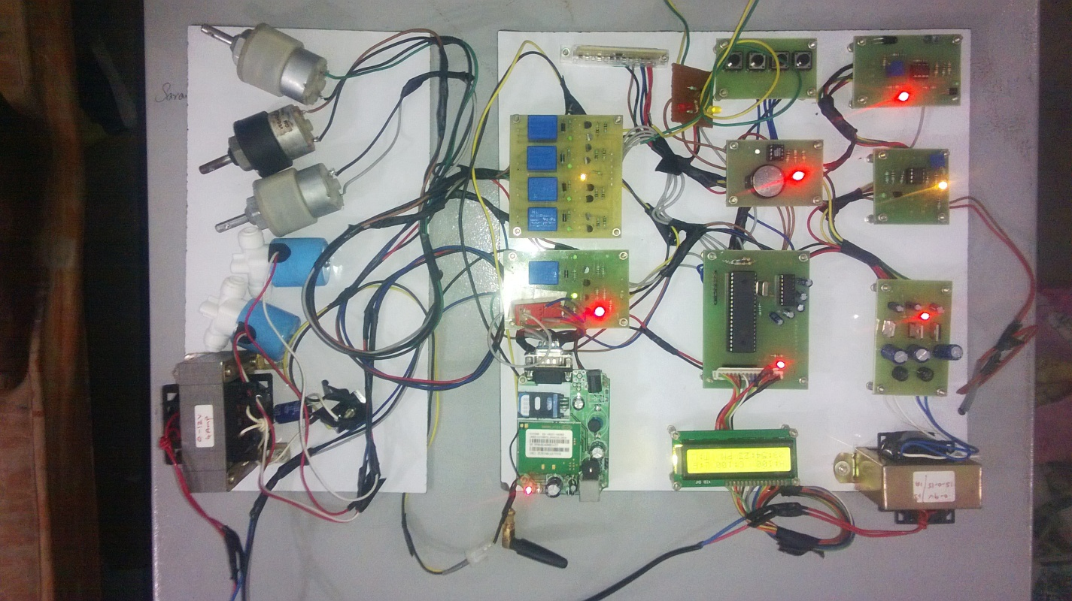

**Fig 4.2.1 Working Model**

The working of the system is completely based on the feedback given from administrator through GSM. The activation can be done using SMS. When the correct password is sent to the machine the microcontroller activates the machine. The time can be displayed in the LCD using RTC. We select the drinks with help of keypads and also through a personal computer. After selecting the items the microcontroller switch on the relays to mix the ingredients. Then the microcontroller asks for placing the cup. The cup dispenser places the cup in the correct position to fill the drink.

The IR sensor is used to find whether the cup is places or not. After placing the cup the microcontroller activates the particular solenoid to pour the drinks into the cup. The microcontroller stores the time of the process in the EEPROM and displays it in LCD. Similarly the water level and temperature of the drinks also displayed in the LCD. If the temperature is greater than the particular level the cooler LED will on.

Similarly if the temperature is lower than the limit the heater LED will on. The time stored is in the EEPROM can be viewed in the PC as well as in the mobile phone. The keypad is used to select the items manually and refill the reaming cups to a particular level. Whenever the tank is empty, an alert message is sent to the administrator through wireless communication. Also the stock/ sales updates and the transaction details is submitted to the administrator at the end of the day.

**4.2 MDB SIMULATION**

A Virtual Environment was created using LabVIEW to simulate the MDB. The VI consists of several selection switches which resemble the ones in the MDB. This gives a user interface where the user can select the drinks and remit the amount accordingly. The VI calculates the amount required for the drink selected and will refund the excess amount. Once the amount has been remitted by the user the MDB shows various options for him to select from. If the user selects a drink lesser in value than he remitted the MDB gives him an option of selecting more drinks with the remaining amount.

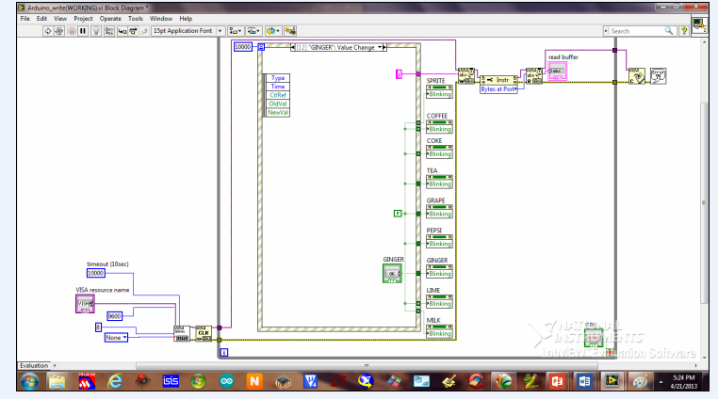

**Fig 4.2a: Block Diagram Panel**

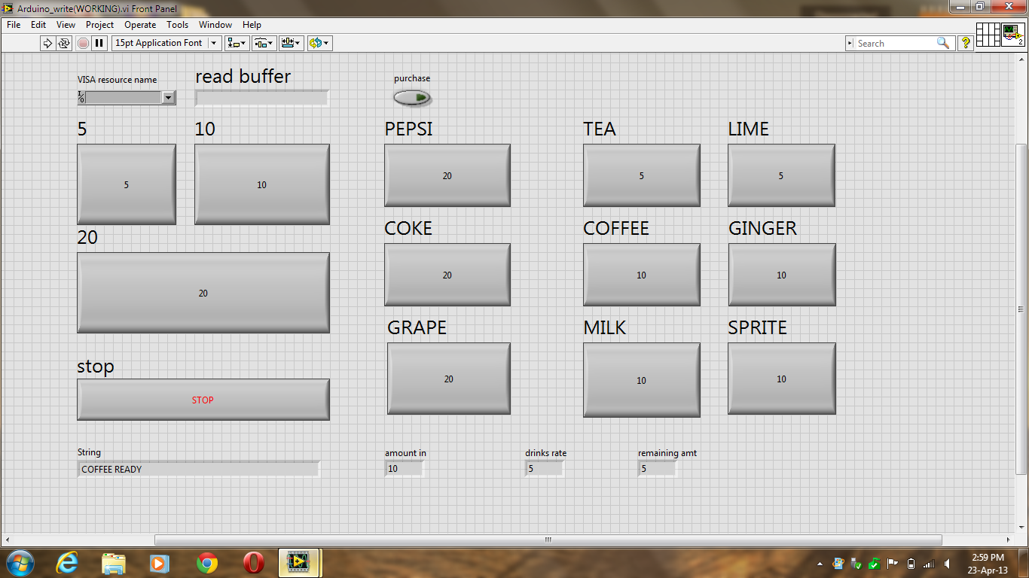

**Fig 4.2b: Front Panel**

**CHAPTER 5**

**CONCLUSION**

The proposed system brings complete automation through GSM wireless communication. It provides password authentication on machine restart. The proposed system also achieves remote monitoring of systems. The system provides high degree of security through password authentication and reliability through alerts and notifications.

The real time stock/sales updates can be received through GSM technique. The transaction data can be stored and retrieved anytime with the help of Secured Digital Card.

**FUTURE WORKS**

The proposed system accepts single-cycle user input and it can be enhanced to multi-cycle user input in the future. In the present systems, the user has to select the items manually and it could be made user interactive through audio and video interface. This would increase sales, profitability, highly efficient, enhance convenience and supports strategic marketing.

In addition to that two or more machines which are physically isolated and remotely inaccessible could be monitored using an application written on PC. This would be more efficient and also would be highly reliable.

**REFERENCES**

1. [‘Vending Machines Going Cashless](http://www.credit.com/blog/2011/03/vending-machines-going-cashless/)’.,Credit.com. 5 March 2011. Retrieved 25 March 2011.

2.<http://www.intel.ie/content/dam/doc/white-paper/retail-core-vending-hardware-referencepaper.pdf>

3. <http://forums.ni.com/t5/LabVIEW/How-to-interface-Labview-with-smart-phones-android-via-Bluetooth/td-p/1875807>

4.http://www.witura.com/img/gsm\_vending\_machine\_monitoring\_and\_control\_system.swf

5. Jeffrey Travis, Jim Kring: *LabVIEW for Everyone: Graphical Programming Made Easy and Fun, 3rd Edition*, July 27, 2006, Prentice Hall. Part of the National Instruments Virtual Instrumentation Series.[ISBN 0-13-185672-3](http://en.wikipedia.org/wiki/Special:BookSources/0131856723)

6. ["ARM and the man"](http://www.techdesignforums.com/eda/volumes/volume-3/march-2006/arm-and-the-man/). *Tech Design Forum* (The Curation Company). March 01, 2006. Retrieved March 21, 2012.

7. [www.ni.com/white-paper/14393/en](http://www.ni.com/white-paper/14393/en)

8. [www.usatech.com/eport/.../2004\_NAMA\_cashless\_vend\_study.pdf](http://www.usatech.com/eport/.../2004_NAMA_cashless_vend_study.pdf)

9.[http://www.youtube.com/watch?v=JWiyQMmQd4shttp://www.coinco-europe.com/manuals/928710%20Virtual%20MDB%20Test%20Box%20Manual.pdf](http://www.youtube.com/watch?v=JWiyQMmQd4shttp://www.coinco-europe.com/manuals/928710%20Virtual%20MDB%20Test%20Box%20Manual.pdf" \t "_blank)

[1] <http://www.dare.co.in/opportunities/services/the-business-of-vending-machines.htm>

**APPENDIX**

**A.CODING**

#include <REGX52.H>

#include<lcd.h>

#include<i2c\_atmel.h>

#include<rtc\_atmel.h>

#define PC 1

#define GSM 0

sbittsol = P2^6;

sbitmrly = P2^7;

sbittempr = P3^2;

sbitir = P3^3;

sbitcsol = P3^4;

sbit mrly1 = P3^5;

sbit mrly2 = P3^6;

sbit mrly3 = P3^7;

sbitlev = P1^2;

sbit red = P1^6;

sbityel = P1^7;

voidser\_init();

voidgsm\_init();

voidmsg\_send();

voidser\_out(unsigned char);

voidser\_dis(unsigned char\* dat, unsigned char no);

void active();

voidtea\_f();

voidcafe\_f();

voidkey\_data();

voidpc\_data();

voidstatus\_mon();

unsigned char rx\_rc[10],rc,j,cold,hot,add,tempt,tempc,ii,ph[20],n,sd\_data;

unsignedintmsg\_cnt;bitok,finish;

void main()

{

mrly=GSM;cold=100;hot=100; mrly1=mrly2=mrly3=tsol=csol=0;yel=red=1;

lcd\_init();

ser\_init();

read(0x80);

lcd\_disp(" AUTOMATIC ",16);

read(0xc0);

lcd\_disp("VENDING MACHINE ",16);

del();del();

gsm\_init();

while(ok==0) active();

del();

read(0x80);

lcd\_disp("T:100 C:100 W:F",16);

read(0xc0);

lcd\_disp(" T:H",16);

rtc\_init();

mrly=PC;

while(1)

{

msg\_cnt++;

all\_disp();

key\_data();

if(rc>1)pc\_data();

status\_mon();

if(msg\_cnt>=1000);

msg\_send();

}

}

voidstatus\_mon()

{

if(lev==0)

{

read(0x8f);write('F');

}

else

{

read(0x8f);write('E');

}

if(tempr==1)

{

yel=0;red=1;

read(0xCf);write('L');

}

else

{

yel=1;red=0;

read(0xCf);write('H');

}

}

voidpc\_data()

{

rc=0;

if(rx\_rc[1]=='1')

{

cold--;

read(0xc0);

lcd\_disp("COLD DRINKS",12);

read(0x82);

write(cold/100+0x30);

write((cold/10)%10+0x30);

write(cold%100+0x30);

tea\_f();

}

else if(rx\_rc[1]=='2')

{

hot--;

read(0xc0);

lcd\_disp("HOT DRINKS",12);

read(0x89);

write(hot/100+0x30);

write((hot/10)%10+0x30);

write(hot%100+0x30);

hot\_f();

}

else if(rx\_rc[1]=='3')

{

read(0xc0);

lcd\_disp("COLD DETAILS ",12);

ee\_init();

for(ii=1;ii<=(tempt\*3);ii++)

{

sd\_data=i2c\_read(ii+125);

ser\_out((sd\_data/10)%10+0x30);

ser\_out(sd\_data%100+0x30);

if(ii%3!=0)ser\_out(':');

elseser\_out(0x0d);

}

}

else if(rx\_rc[1]=='4')

{

read(0xc0);

lcd\_disp("HOT DETAILS",12);

for(ii=1;ii<=(tempt\*3);ii++)

{

sd\_data=i2c\_read(ii);

ser\_out((sd\_data/10)%10+0x30);

ser\_out(sd\_data%100+0x30);

if(ii%3!=0)ser\_out(':');

elseser\_out(0x0d);

}

}

}

voidmsg\_send()

{

mrly=GSM;del();

ser\_dis("AT+CMGS=",8);

ser\_out('"');

for(ii=0;ii<=n-1;ii++) ser\_out(ph[ii]);

ser\_out('"');

ser\_out(0x0D);

ser\_dis("COLD ",3);

ser\_out(cold/100+0x30);

ser\_out((cold /10)%10+0x30);

ser\_out(cold %100+0x30);

ser\_dis("HOT",4);

ser\_out(hot/100+0x30);

ser\_out((hot/10)%10+0x30);

ser\_out(hot%100+0x30);

ser\_out(0x1A);

del();

mrly=PC;

}

voidkey\_data()

{

if(set==0)

{

time\_set();

read(0x80);

lcd\_disp("T: C: W:F",16);

read(0x82);

write(cold /100+0x30);

write((cold /10)%10+0x30);

write(cold %100+0x30);

read(0x89);

write(hot/100+0x30);

write((hot/10)%10+0x30);

write(hot%100+0x30);

}

else if(cur==0) //refill

{

read(0x80);

lcd\_disp("T:100 C:100 W:F",16);

cold=100; hot=100;

read(0x82);

write(cold /100+0x30);

write((cold /10)%10+0x30);

write(cold %100+0x30);

read(0x89);

write(hot/100+0x30);

write((hot/10)%10+0x30);

write(hot%100+0x30);

}

else if(incr==0)

{

cold--;

read(0xc0);

lcd\_disp("COLD SELECTED",12);

read(0x82);

write(cold /100+0x30);

write((cold /10)%10+0x30);

write(cold %100+0x30);

cold\_f();

}

else if(decr==0)

{

hot--;

read(0xc0);

lcd\_disp("HOT SELEC'D",12);

read(0x89);

write(hot/100+0x30);

write((hot/10)%10+0x30);

write(hot%100+0x30);

hot\_f();

}

}

void cold \_f()

{

tempt++;

mrly1=1; del(); mrly1=0;

mrly2=1; del();del();mrly2=0;

mrly3=1; del();del();del();mrly3=0;

read(0xc0);

lcd\_disp("PLACE UR CUP",12);

while(ir==1);

tsol=1; del(); del(); tsol=0;

ee\_init();

add=tempt+125;

if(add>=155)

{

read(0xc0);

lcd\_disp("memory full",12);

}

else

{

i2c\_write(add,hour);add++;

i2c\_write(add,min);add++;

i2c\_write(add,sec);

}

rtc\_init();

all\_disp();

}

voidhot\_f()

{

tempc++;

mrly1=1; del();del();del(); mrly1=0;

mrly2=1; del();del();mrly2=0;

mrly3=1; del();mrly3=0;

read(0xc0);

lcd\_disp("PLACE UR CUP",12);

while(ir==1);

csol=1; del(); del(); csol=0;

ee\_init();

add=tempc;

if(add>=30)

{

read(0xc0);

lcd\_disp("memory full",12);

}

else

{

i2c\_write(add,hour);add++;

i2c\_write(add,min);add++;

i2c\_write(add,sec);

}

rtc\_init();

all\_disp();

}

void active()

{

read(0x80);

lcd\_disp(" PLESE ACTIVATE ",16);

read(0xc0);

lcd\_disp(" DEVICE USG PSW ",16);

EA=ES=1;

ser\_dis("AT+CMGR=1",9);ser\_out(0x0d);del();

if(rc>=5)

{

EA=ES=0;

read(0x80);

lcd\_disp(" MSG RCVD ",16);

if(rx\_rc[0]=='\*'&&rx\_rc[1]=='1'&&rx\_rc[2]=='1' &&rx\_rc[3]=='0'&&rx\_rc[4]=='0')

{

read(0x80);lcd\_disp("PASSWORD CORRECT",16);

read(0xc0);lcd\_disp("DEVICE ACTIVATED",16);

ok=1;

}

else

{

read(0x80);lcd\_disp("PASSWRD IN CORCT",16);

read(0xc0);lcd\_disp(" TRY AGAIN ",16);

ok=0;

}

ser\_dis("AT+CMGD=1",9);ser\_out(0x0d);del();

rx\_rc[0]=rx\_rc[1]=rx\_rc[2]=rx\_rc[3]=rx\_rc[4]=0;rc=0;

}

EA=ES=1;

del();

}

voidser\_init()

{

EA=ES=0;

TI=0;

SCON=0X50;

TMOD=0X21;

TH1=0Xfd; //9600

TR1=1;

}

voidser\_int() interrupt 4

{

if(RI)

{

RI=0;

rx\_rc[rc]=SBUF;

if(finish==1)

{

if(rx\_rc[0]=='\*' ) rc++;

elserc=0;

}

else if(finish==0)

{

if(rx\_rc[0]==',' ) rc++;

elserc=0;

if(rc>9 &&rx\_rc[rc-1]==',' ) finish=1;

if(rc>15) rc=0;

}

}

}

voidgsm\_init()

{

read(0x01);

read(0x80);

lcd\_disp("GSM INITILIZATION",16);

read(0xc0);

lcd\_disp("WAITING..........",16);

for(ii=0;ii<=15;ii++)

{

read(0xce);

write(((ii%100)/10)+0x30);

write(ii%10+0x30);

del();

}

ser\_dis("AT",2);ser\_out(0x0d); del();

ser\_dis("AT",2);ser\_out(0x0d); del();

ser\_dis("AT+CMGF=1",9);ser\_out(0x0d);del();

ser\_dis("AT+CPBF=",8);

ser\_out('"');

ser\_out('1');

ser\_out('"');

ES=1;del();ser\_out(0x0d);

while(finish==0);

ES=0;

read(0x01);

read(0x80);

for(ii=2;ii<=rc-3;ii++) {ph[n]=rx\_rc[ii];write(ph[n]);n++;}

ser\_dis("AT+CMGD=1",9);

ser\_out(0x0d);del();

rc=0;

}

voidser\_dis(unsigned char\* dat, unsigned char no)

{

unsigned char ia;

for(ia=0;ia<no;ia++)

{

ser\_out(dat[ia]);

}

}

voidser\_out(unsigned char dat)

{ SBUF= dat;

delay(255);

SCON=0x58;

delay(8000);

}

}

**B. DATASHEETS**

**THERMISTOR**

**SPECIFICATIONS OF NTC:**

• Temperature range: -40°C ~ +125°C

• Dissipation factor: 4.5mW/°C (@25°C)

• Maximum power rating: 450mW (@25°C)

• Life: almost indefinite

**ELECTRICAL CHARACTERISTICS:**

**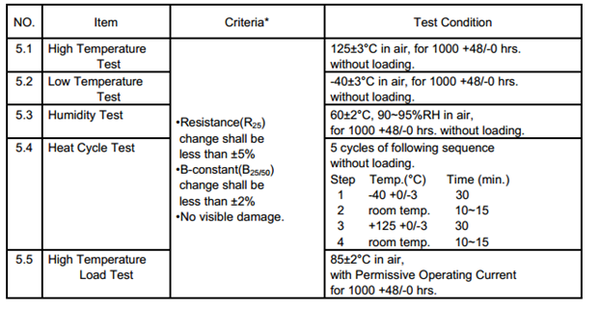**

**AT1: Electrical Characteristics of NTC**

**MECHANICAL CHARACTERISTICS:**

**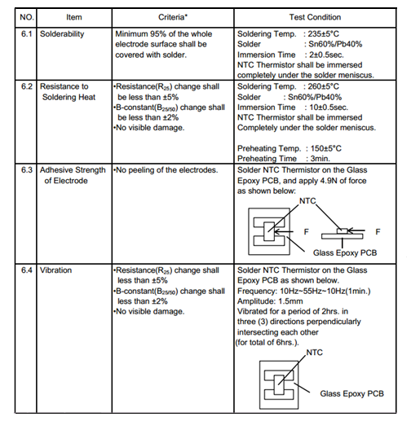**

**AT2: Mechanical Characteristics of NTC**

**RELAY DRIVER ULN2003**

**FEATURES**

* Output Current (Single Output): 500mA (MAX.)
* High Sustaining Voltage Output: 50V (MIN.)
* Output Clamp Diodes
* Inputs Compatible With Various Types Of Logic

**PIN DIAGRAM**

**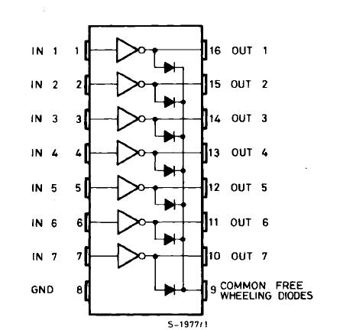**

**AF1: Pin diagram of ULN2003**

**ELECTRICAL CHARACTERISTICS** (TA=25°C unless otherwise specified)

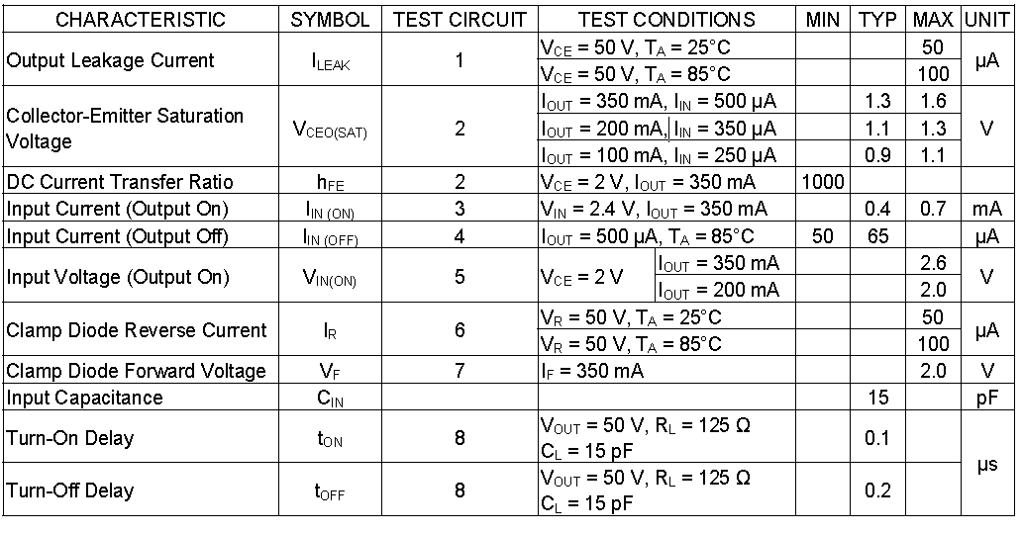

**AT3: Electrical Characteristics of ULN2003**

**DM7400**

**PIN DIAGRAM**



**AF2: Pin Diagram of DM7400**

**TRUTH TABLE:**

**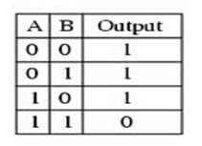**

**AT4: Truth Table of NAND**

**OPERATING CONDITION**

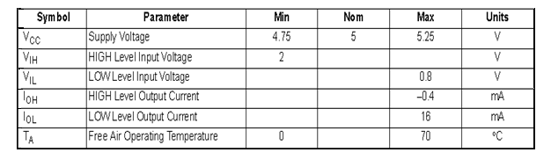

**AT5: Operating Condition of DM7400**

**ELECTRICAL CHARACTERISTICS**

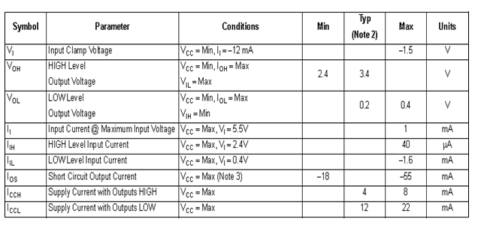

**AT6: Electrical characteristics of DM7400**

**TRANSISTOR BC547**

**SWITCHING APPLICATIONS**

• High Voltage: BC546, VCEO=65V

• Low Noise: BC549, BC550

• Complement to BC556 ... BC560

**PIN DIAGRAM**

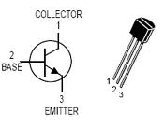

**AF3: Pin Diagram of BC547**

**ELECTRICAL CHARACTERISTICS**

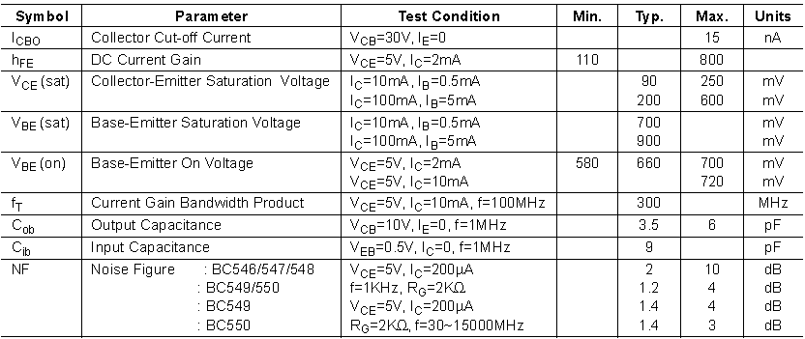

**AT7: Electrical Characteristics of BC547**

**ATMEGA 128**

**PIN DIAGRAM**

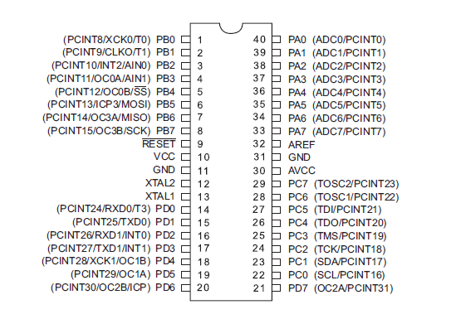

**AF4: Pin Configuration of ATmega128**

**ELECTRICAL CHARACTERISTICS**

**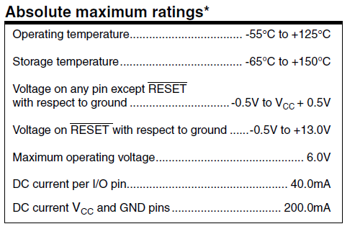**

**AT8: Electrical Characteristics of ATmega128**

**DC CHARACTERISTICS**

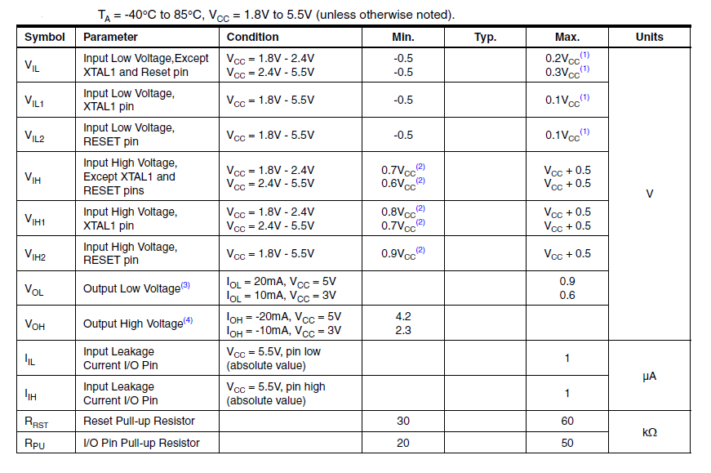

**AT9: DC Characteristics of ATmega128**